**ShipSmart**

|  |  |
| --- | --- |
| Course: CSIT 515-01: Software engineering & Reliability  Instructor: Dr. Hubert Johnson    **USER MANUAL** |  |
| By Software Chasers  Heba Shubib  Pragati Gupta  Sagina Athikkal  Tejaswi Kukalakunta |  |

Course: CSIT 515-01: Software engineering & Reliability

Instructor: Dr. Hubert Johnson

Contents

Contents

**1. Introduction** 2

**1.1 Purpose of the System** 2

**1.2 Project Goals** 2

**1.3 Purpose of the Current Document** 2

**2. How to launch the System** 2

**3. User’s Manual** 6

**3.1 How to Navigate the System** 6

**3.1.1 Customer’s view pages** 6

**3.1.2 Admin’s view** 8

**4. Customer’s Manual** 8

**4.1 Sign Up** 8

**4.2 Log in** 10

**4.3 Create Shipment** 11

**4.4 Track shipment** 17

**4.5 Rates quote** 19

**4.6 About Us** 21

**4.7 Contact Us** 21

**5. Admin’s Manual** 22

**5.1 Orders** 22

**5.2 Add/Update Tracking** 23

**5.4 Logout** 24

# **1. Introduction**

## **1.1 Purpose of the System**

ShipSmart is a software system which offers cross states shipping and international shipping as well. ShipSmart software will be an operation-management tool which will be built to meet industry-specific needs for domestic and cross-border logistics. ‘Software Chasers’ will develop a single system for the company to meet its operations, accounting, visibility and tracking, connectivity and compliance needs. It will also provide a solution to an end-to-end supply chain management for logistics.

## **1.2 Project Goals**

Software Chasers will develop a system that will help the PATCO Shipping company to manage the company’s shipping operation end to end. This system will help PATCO to attract new clients as well as maintain a good retention rate. The goal of Software Chasers is to create software for the client.

## **1.3 Purpose of the Current Document**

This User Manual Document will guide ShipSmart System’s user through all ShipSmart System’s pages to ensure a good user experience.

# **2. How to launch the System**

In order to run the system on your desktop/laptop device, please follow the following steps:

1. Download XAMPP server to your device, its free and open-source cross-platform web server solution available for windows, OS X and Linux. To download it please click on this link <https://www.apachefriends.org/download.html>
2. Run XAMPP server and it will display the following screen as in Figure 2.1.

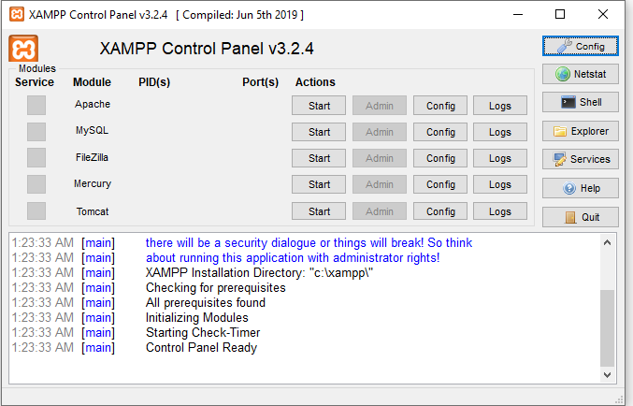

Figure 2.1: XAMPP Control Panel

1. Click on MySQL and Apache start Buttons. Wait until you see green highlighted MySQL and Apache words. Then click on admin button for the MySQL as shown in Figure (2)

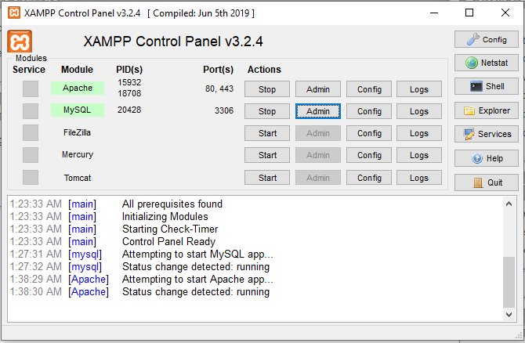

Figure 2.2: Run MySQL

1. Click on import tap on the navigation bar as shown in the below Figure (3).
2. Click on browse button and then select the shipsmart.sql file which included in the database file in ShipSmart Folder.

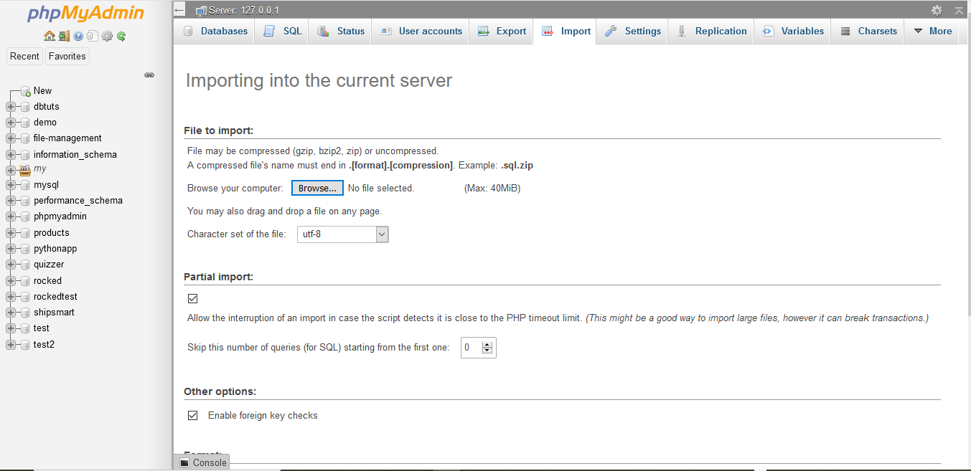

Figure 2.3: php MyAdmin page

1. Click on the Go button then you will receive a successful message telling you that you successfully have imported the database into your server.
2. In order to run the system source code, you need to download eclipse. Click on this link to download it <https://www.eclipse.org/downloads/>. Run eclipse software.

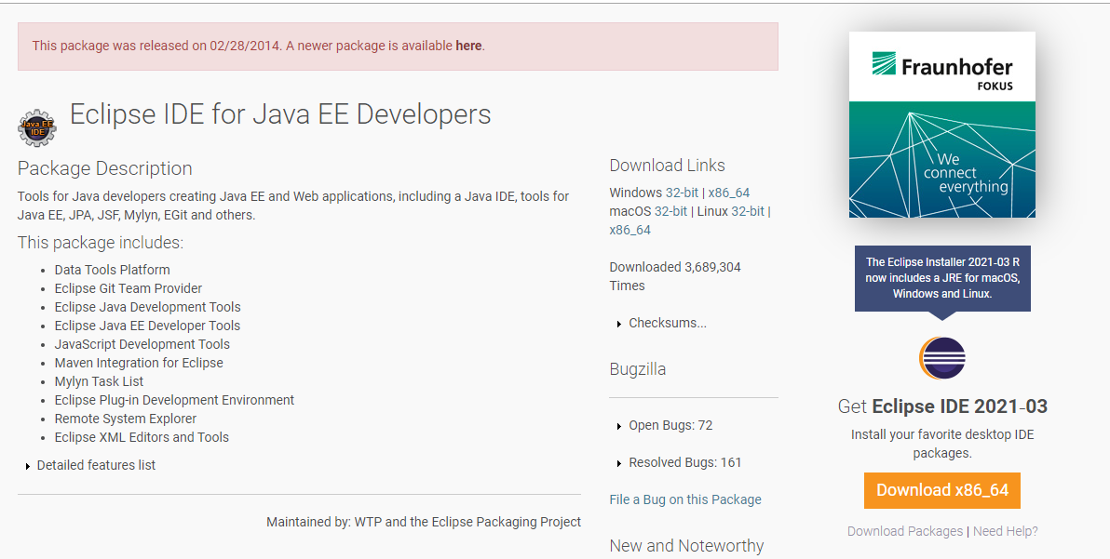

Figure 2.4: Eclipse IDE download

1. Import the project as Maven Project.
2. Run the application as spring boot app as shown in figure.2.5

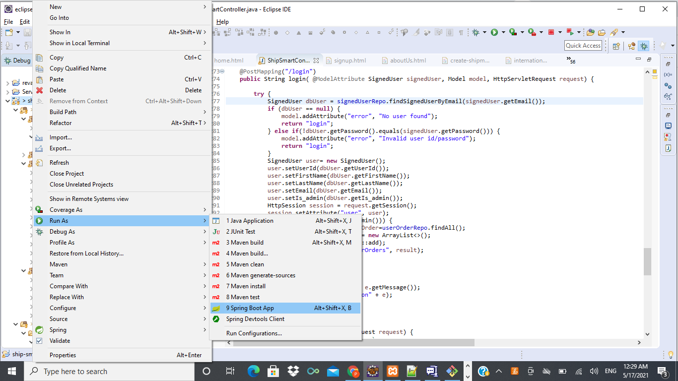

Fig. 2.5 Spring boot app

1. Load the website using the URL [*http://localhost:8080/home*](http://localhost:8080/home)
2. Dependent configuration- the application is using below google account for sending email notifications to the customers.

username: [shippingPATCO98@gmail.com](mailto:shippingpatco98@gmail.com)

password: Happy_123

1. Credentials of Customer care’s Login Account to receive customer queries. The details are:

username: [representativePATCO@gmail.com](mailto:representativepatco@gmail.com)

password: Happy_123

|  |
| --- |
|  |

# **3. User’s Manual**

## **3.1 How to Navigate the System**

ShipSmart has two different views, one for the customer and one for the admin/employee.

### **3.1.1 Customer’s view pages**

Customers are allowed to Sign Up, Login, create a shipment, Schedule pick up for the shipment, International shipping, Online Payment system, explore About Us and Contact Us pages. They also can track their shipment any time using tracking ID. Portal will also provide features to the customer for getting free quotes by entering contact information and submitting it. Customers are also allowed to view the rate calculation of shipping as well as real time status update as shown in Figure 3.1.

All customer’s pages have the same

1. Navigation bar on the top which allows the user to do most of the activities mentioned above.
2. Page footer which includes links for PATCO’s social media platforms.

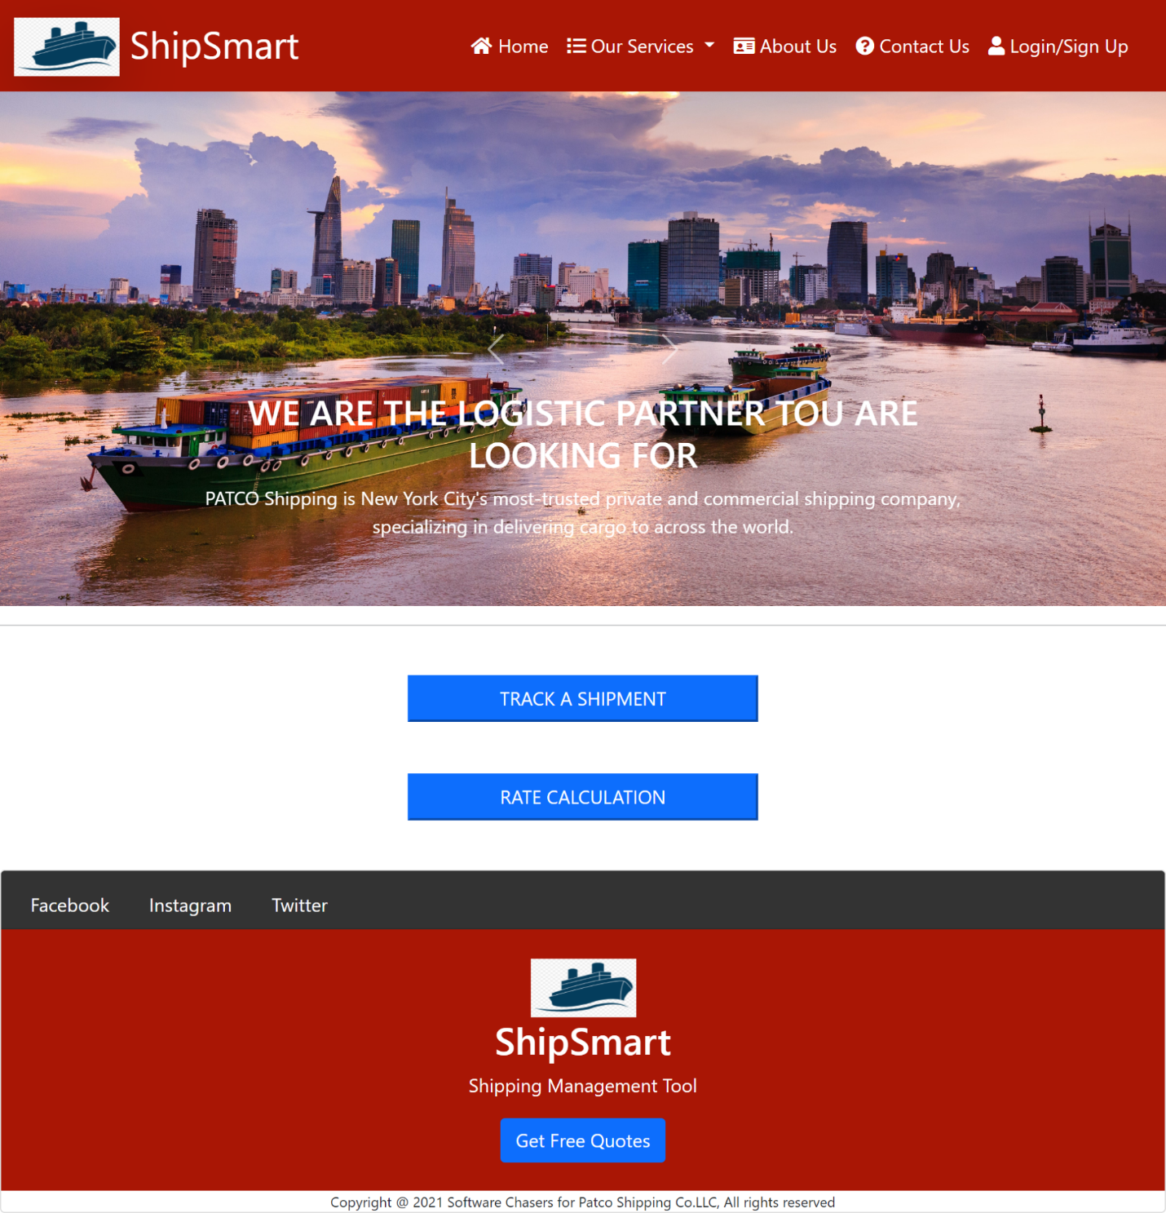

Figure 3.1: Customer view of Home Page

### **3.1.2 Admin’s view**

ShipSmart system’s admin has access to the main functions of ShipSmart system:

* Create Shipment.
* View all customers orders.
* Calculate Shipping prices.
* Track Shipments.
* Create Claims.
* Create Coupons and promo codes.

ShipSmart System has an easy access admin dashboard which allows ShipSmart system’s admin to manage all of the above functions as shown in the following Figure 3.2.

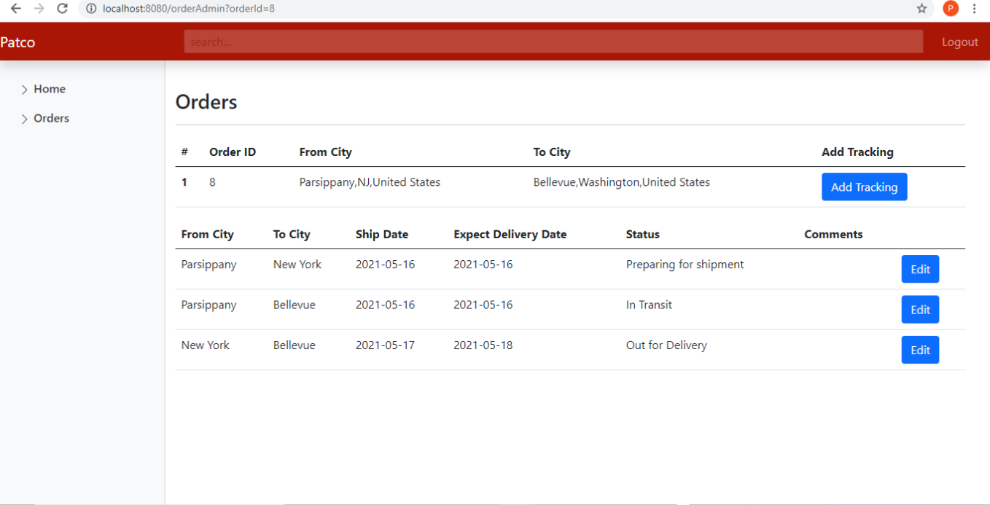

Figure 3.2 Admin Dashboard

# **4. Customer’s Manual**

## **4.1 Sign Up**

* ShipSmart Software’s users can sign up for PATCO company’s system by clicking on the Sign-up tab in the navigation bar as shown in Figure 4.1.

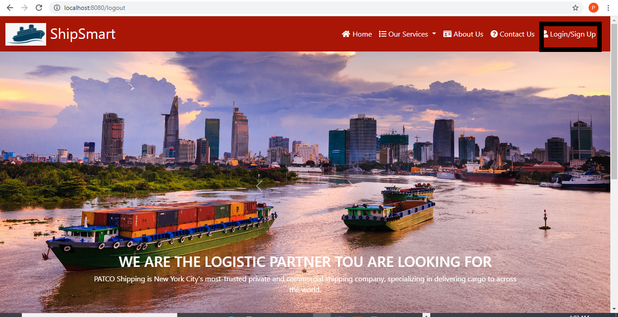

Figure 4.1: Login/signup

* PATCO Customers can sign up by clicking on the Sign-Up Customer tab and fill out the form with the First Name, Last Name, Email Address, Password. Then click on the Create Account button as shown in Figure 4.2.

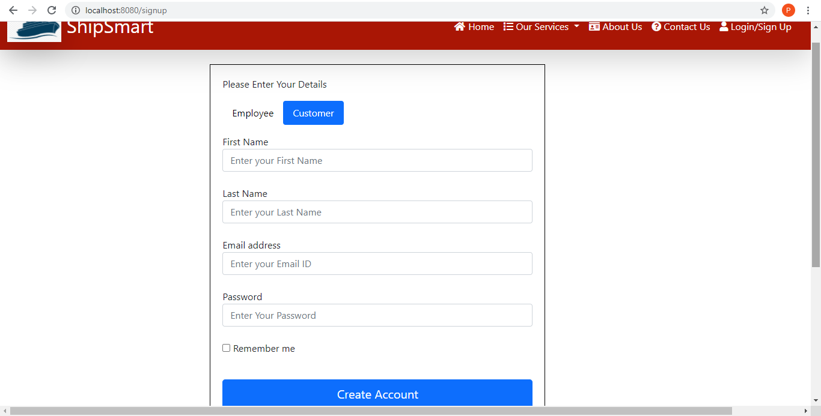

Figure 4.2: Customer Sign Up

* PATCO Company can add admins to the ShipSmart system by clicking on the Sign-Up employee tab and fill out the form with the First Name, Last Name, Employee ID, Email Address, Password. Then click on the Create Account button as shown in Figure 4.3.

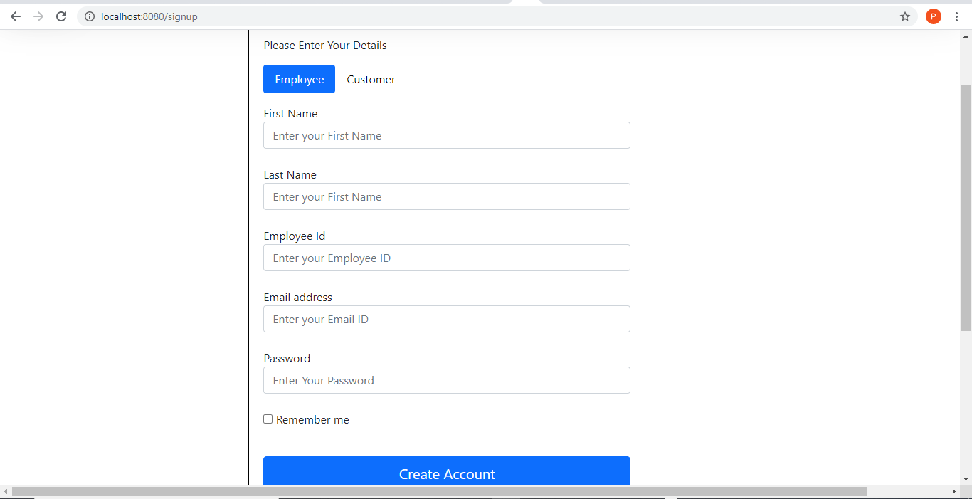

Figure 4.3: Employee signup

## **4.2 Employee/ Customer Log in**

User needs to have an account with ShipSmart to log in. If user has already created account with PATCO through ShipSmart Software then he can select log in option from navigation bar in the main page and then enter user email address and password then click on log in button. If the user does not have an account with PATCO then the user needs to sign up first.

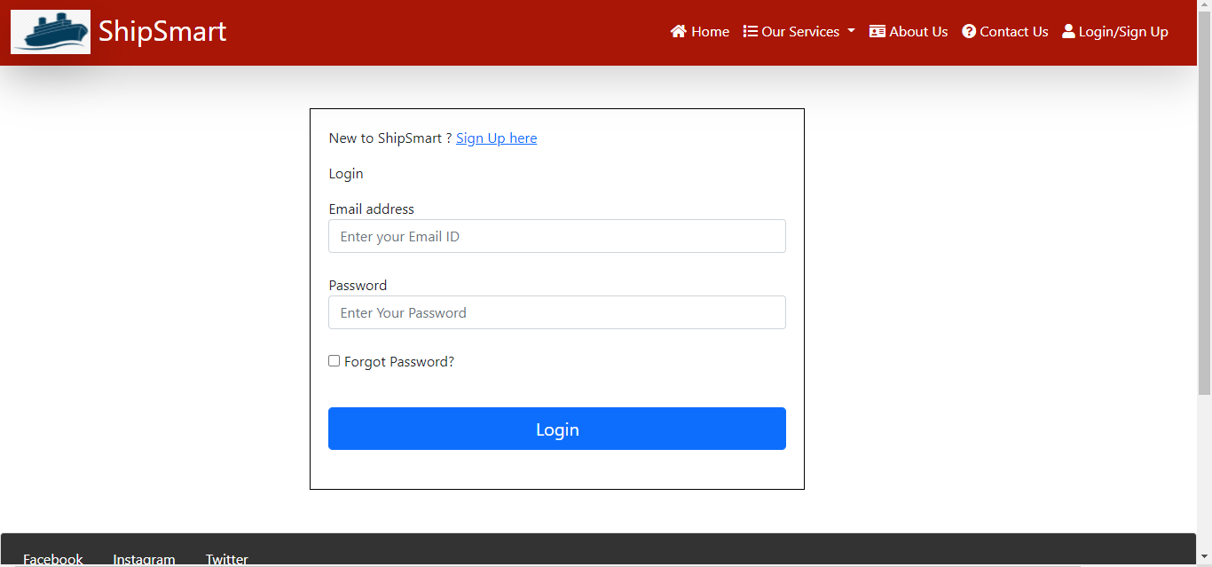

Figure 4.4: Login Page

## **4.3 Create Shipment**

* Once the user logged in, user will get an option for create shipment. “Create shipment” option will be available as dropdown item in “Our Services” navigation bar shown in Figure 4.5

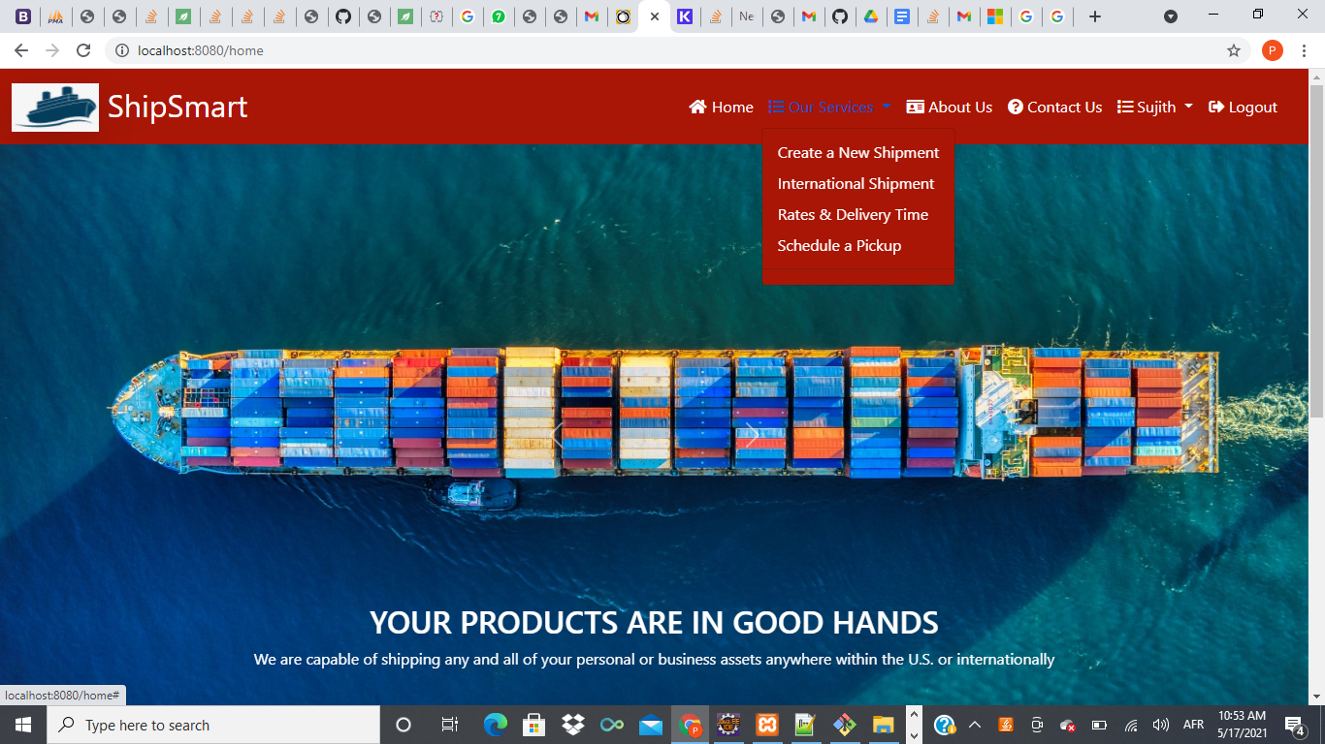

Figure 4.5: Create Shipment

* Once the user clicks on the create shipment, it will navigate the user to the create shipment form as shown Figure 4.6

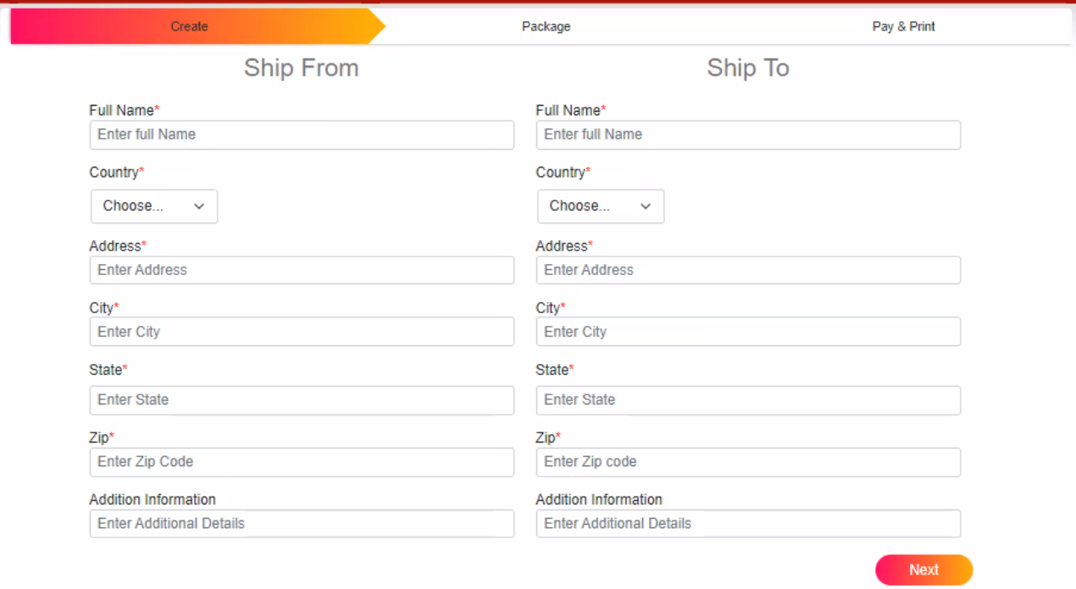

Figure 4.6: Create Shipment Form

* International shipping can be made by selecting country from the drop-down menu as shown in Figure 4.7.

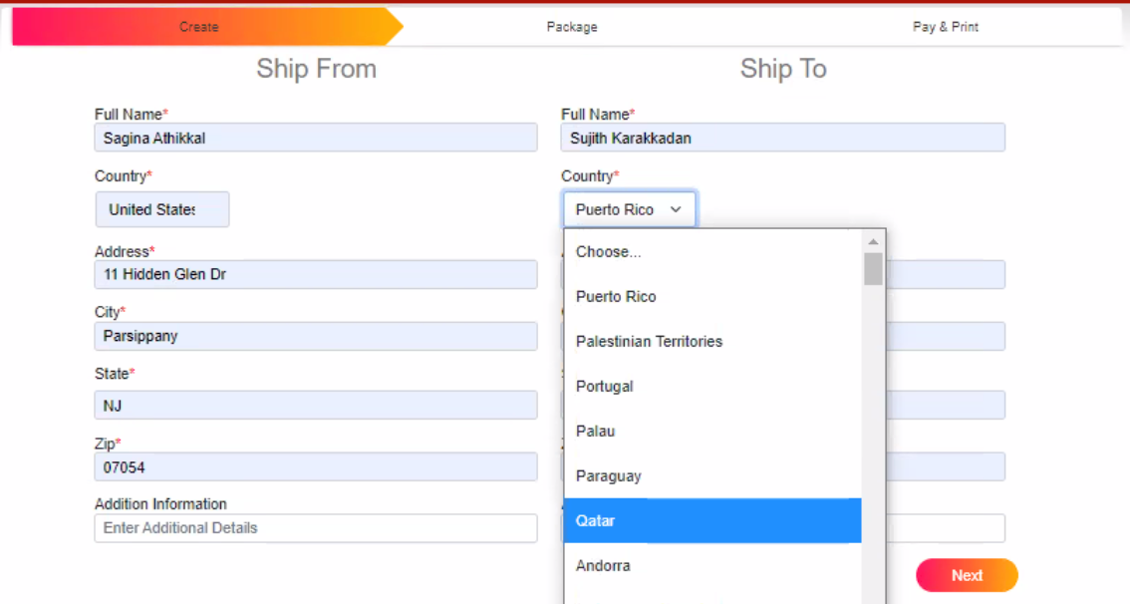

Figure 4.7 Country drop down

* Click on the next button then enter the required fields of package information as shown in Figure 4.8.

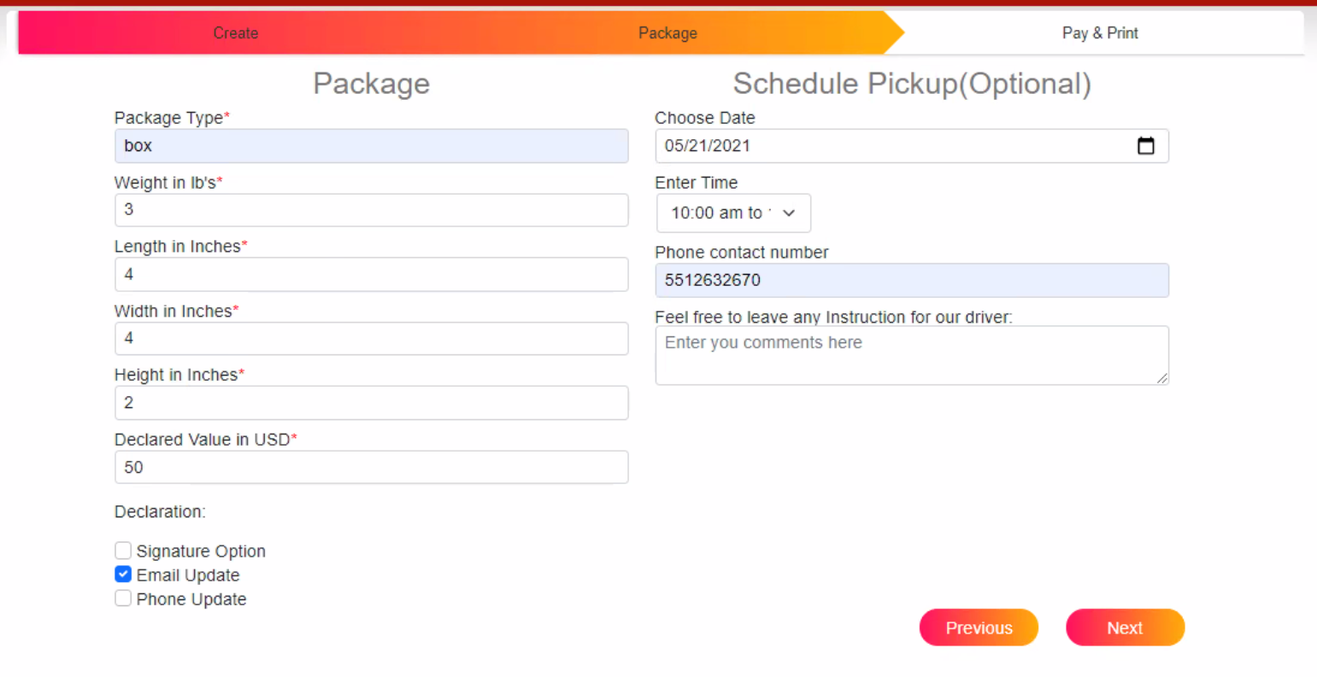

Figure 4.8: Create Shipment Package Information

* Once the user clicks on the next, it will navigate to payment pages. It gives an option for entering coupons and selecting shipment options. The payment options and the coupons can be con Figured in the database. Customer has to enter all the required fields in order to proceed to checkout.

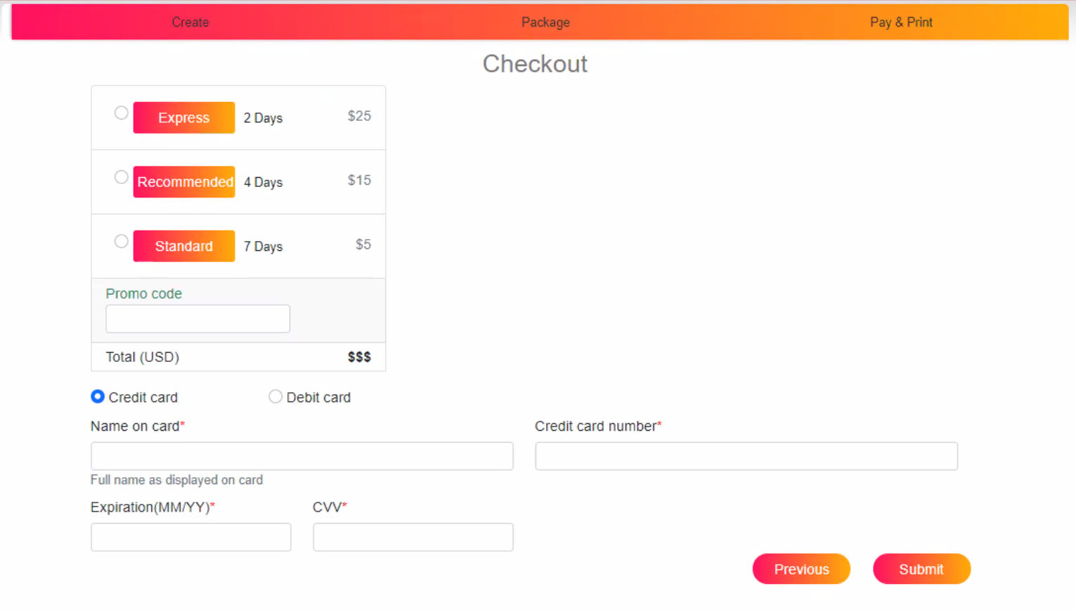

Figure 4.9 Payment Section of Create Shipment

* Once all the mandatory information is entered user can click on submit button to submit the form. It also provides option for navigate back using previous button.
* On submission, it will direct the user to the confirmation page, it will provide dynamically created tracking information with the unique Tracking Id. ShipSmart system will send an email to the customer with the related tracking information for his placed order.

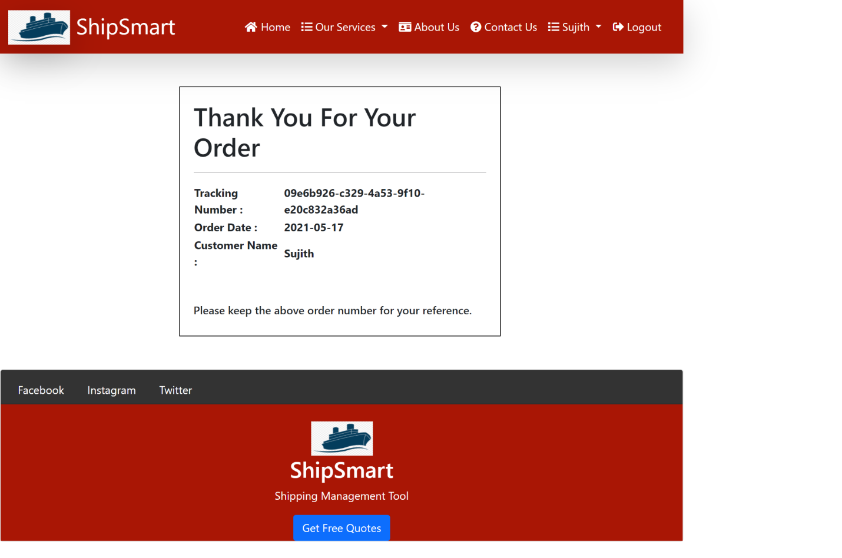

Figure 4.10 Order Confirmation

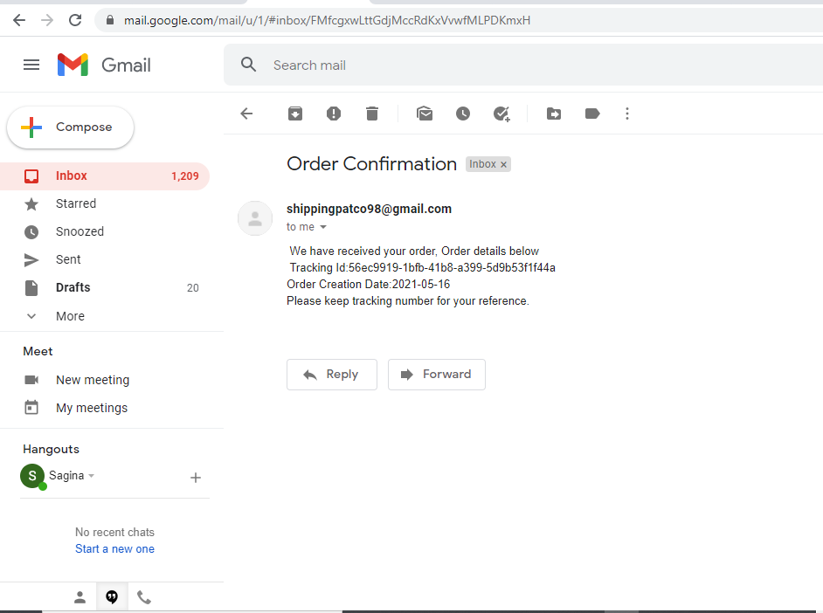

Figure 4.11 Order Confirmation Email

## **4.4 Track shipment**

Users can track a shipment using the tracking ID received at the time of booking. In the home page it will provide an option for tracking the shipment as shown in the Figure 4.12 below.

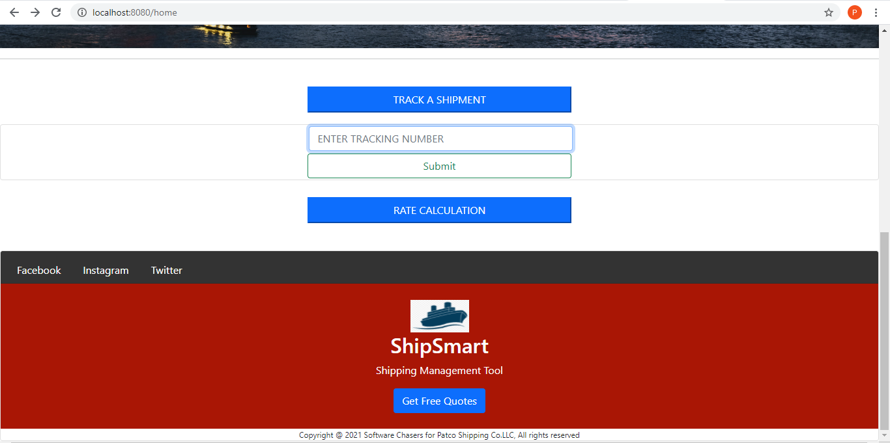

Figure 4.12 Track Shipment

* Enter the unique tracking ID which user received at the time of booking the shipment.

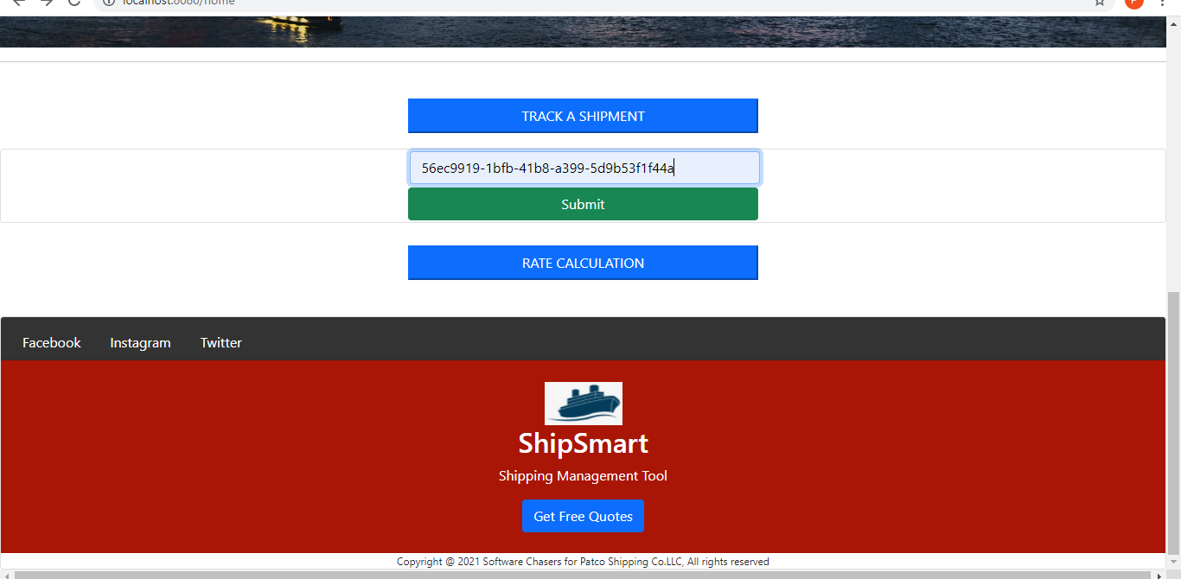

Figure 4.13 Sample of Track Shipment

* Clicking on the “Track A Shipment” button by providing the tracking Id user will directed to the tracking history page; where user can view all the status of the shipment from source to destination.

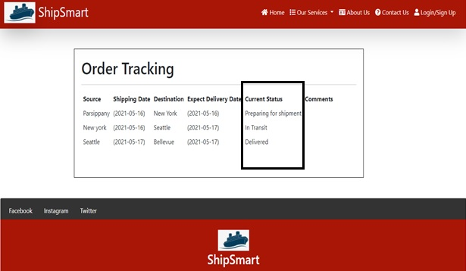

Figure 4.14 Tracking History

## **4.5 Rates quote**

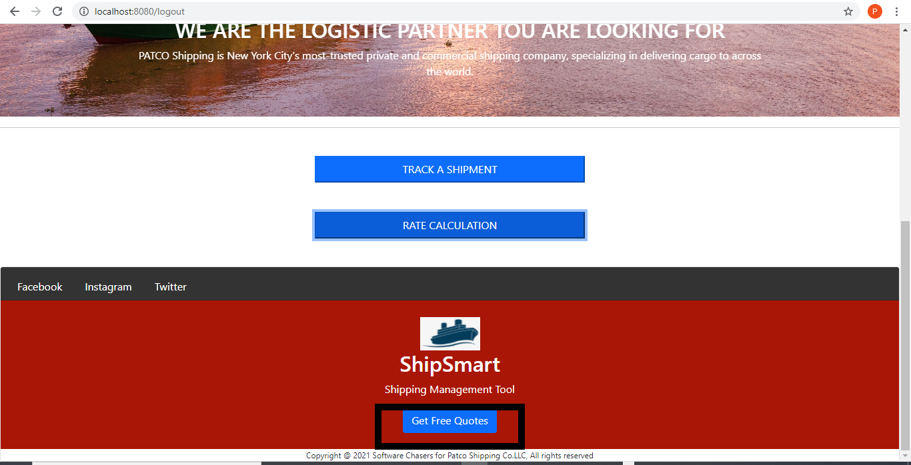The Home page will also provide an option for getting free quotes by submitting the information as shown in the Figure 4.15 below. Once the user clicks on submit button, it will trigger an email to the configured email ID ([representativePATCO@gmail.com](mailto:representativepatco@gmail.com)).

Figure 4.15: Get Free Quote

* User need to enter all the mandatory fields and click on the submit button, it will direct the user to notification of successful submission of the query.

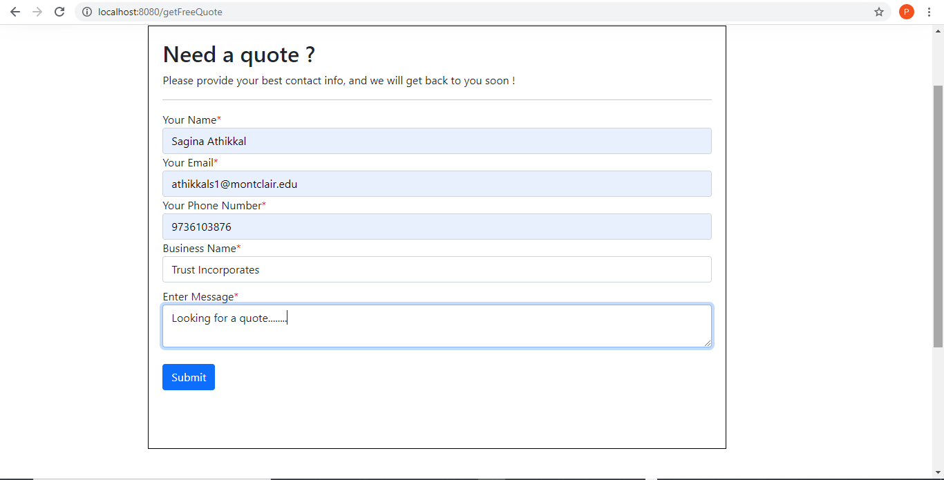

Figure 4.16: Free Quote Form



Figure 4.17: Successful Submission Message

* Once the user clicks on submit button, it will trigger an email to the configured email ID ([representativePATCO@gmail.com](mailto:representativepatco@gmail.com)) as shown in Figure 4.18.

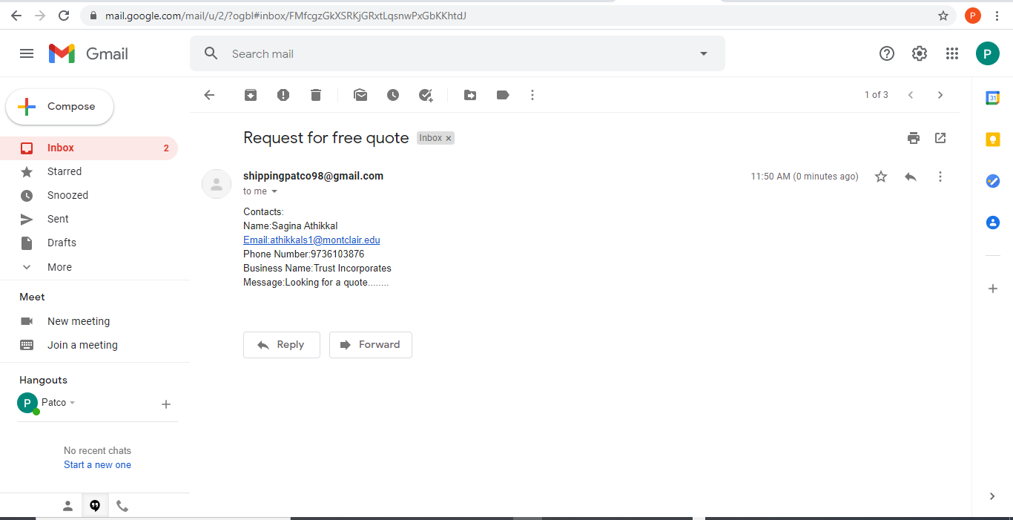

Figure 4.18: Received Customer Quote Request

## **4.6 About Us**

Clicking on the About Us option in the navigation bar will direct the user to the about us page ; which has description about the PATCO company as shown Figure 4.19 below.

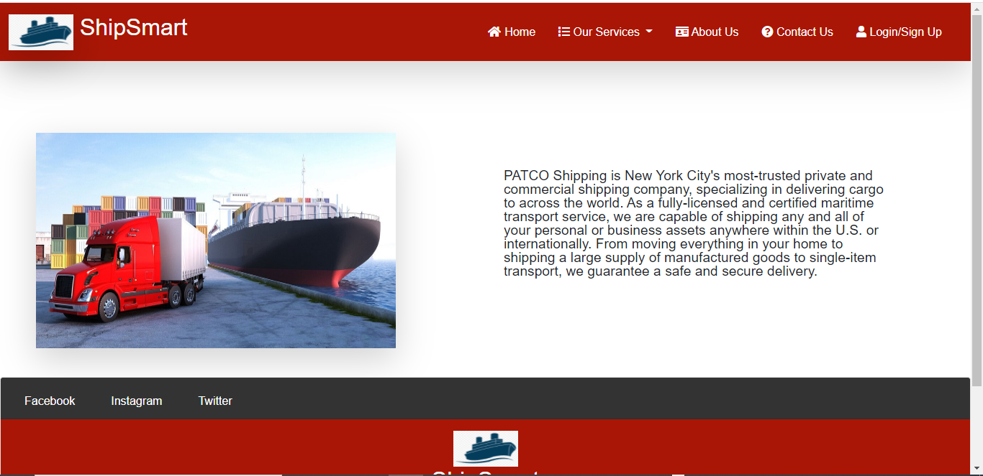

Figure 4.19: About Us

## **4.7 Contact Us**

Clicking on Contact Us option will navigate the users to the Contact Us page as shown Figure 4.20 below. User will be able to view PATCO contact information as well as user can send message by entering the Name, Email address, Phone Number and the Message to PATCO email via Contact Us page.

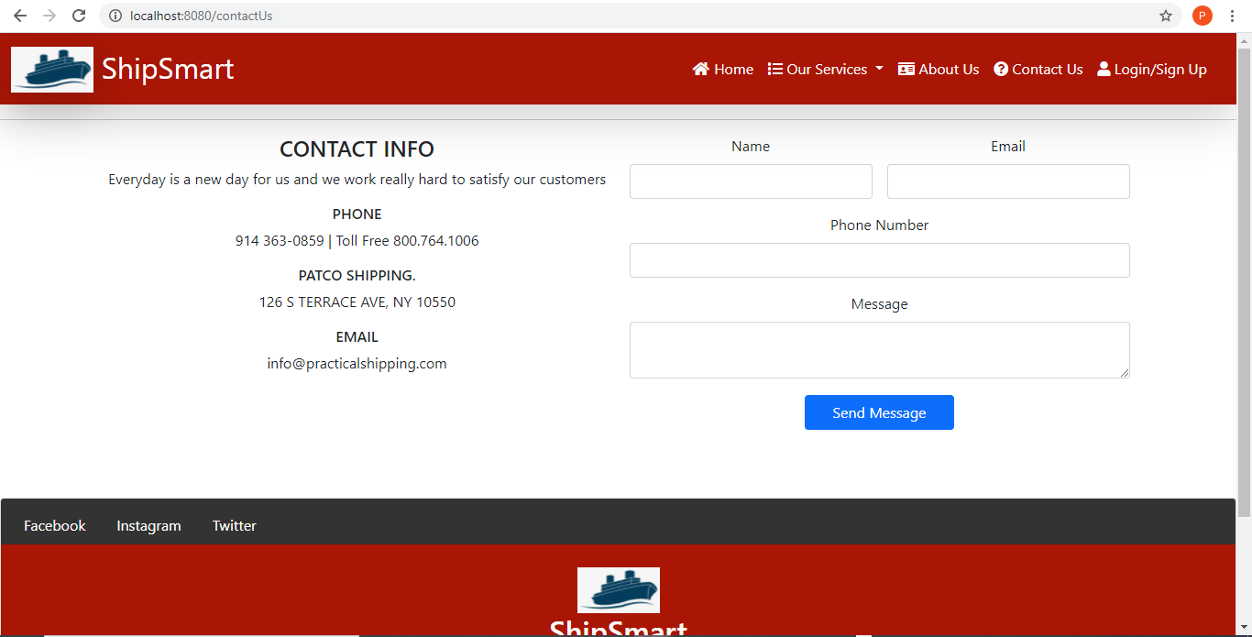

Figure 4.20: Contact Us

# **5. Admin’s Manual**

## **5.1 Orders**

Employee login to the portal, it will navigate the employee to the dashboard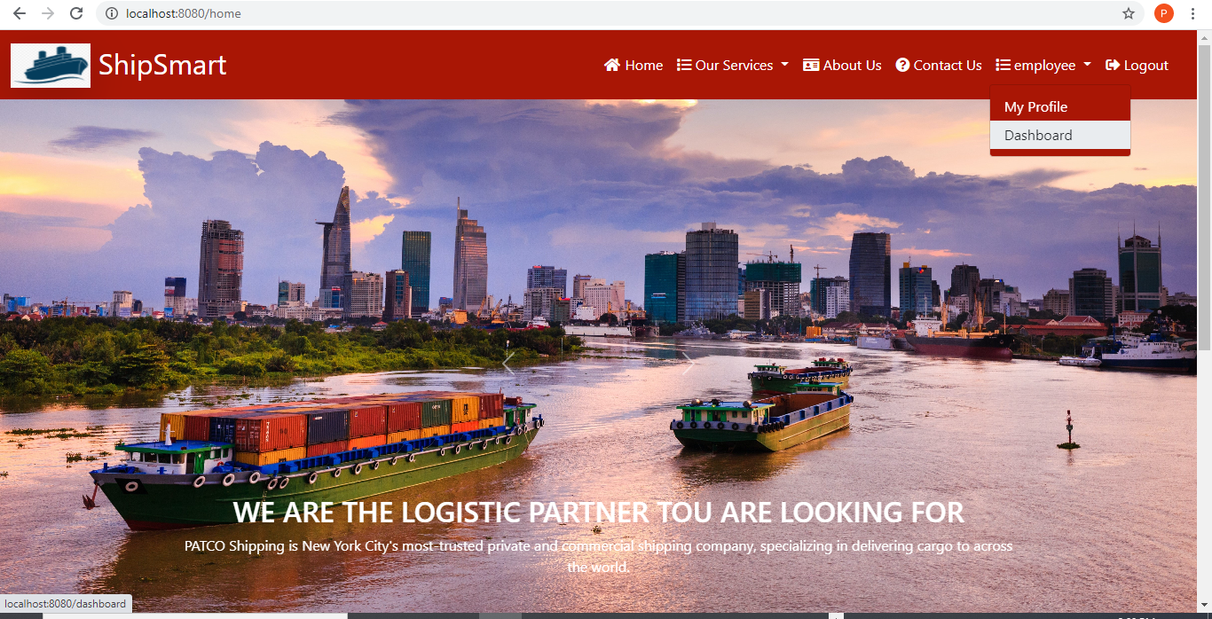 as shown in Figure 5.1. below.

Figure 5.1: Employee Home Page

The dashboard will give all the orders details with the created date. Clicking on the order ID will direct the employee to order information page.

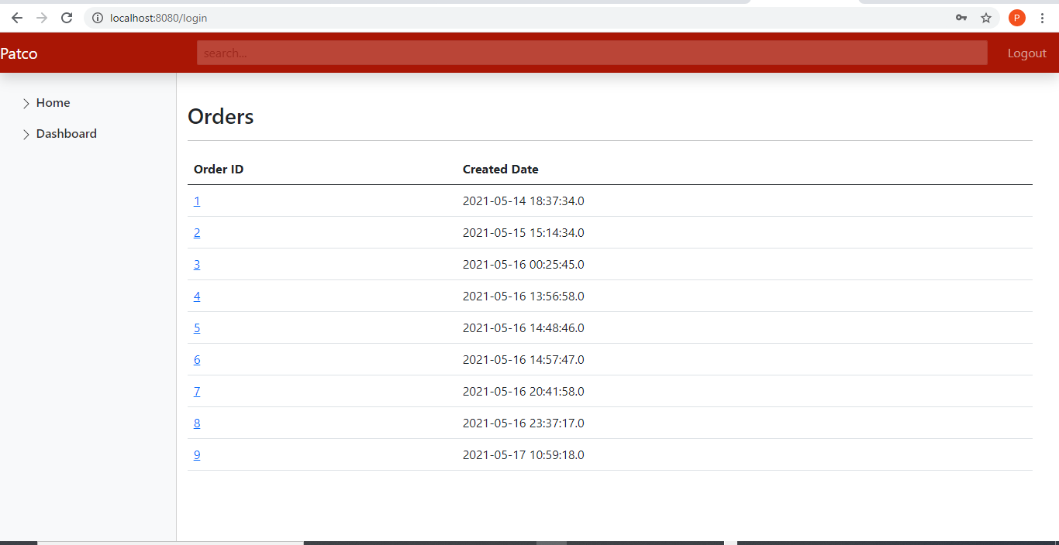

Figure 5.2: Employee Dashboard

## **5.2 Add/Update Tracking**

Employees will get more details/information about the customer order. It will provide an option for the employee to add/update/delete tracking. The Tracking details updated here will become available for the users, when the user will click the track a shipment button at the home page as shown in the Figure 5.3.

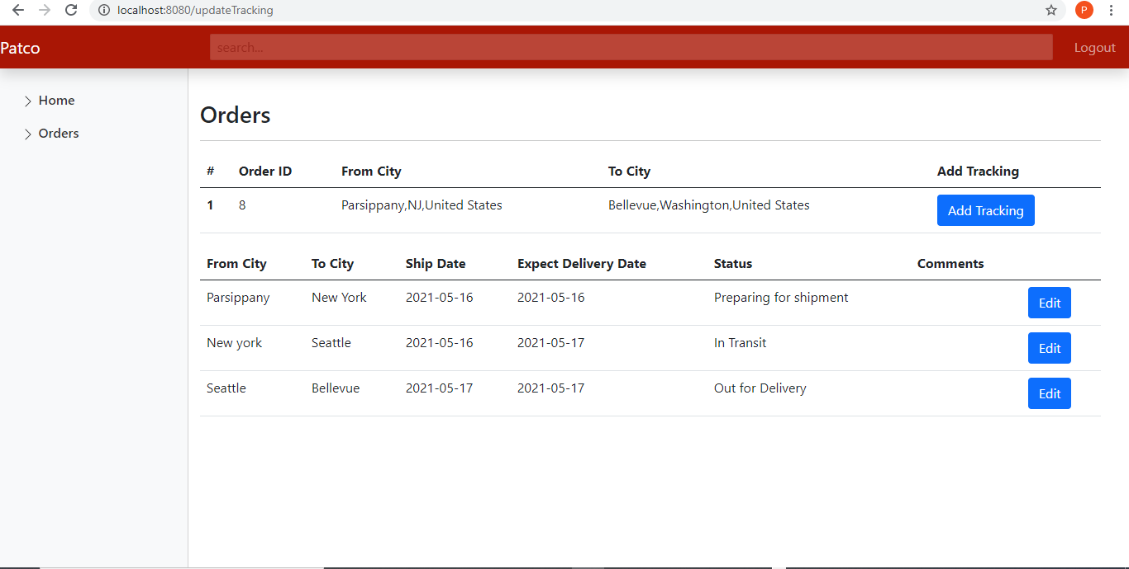

Figure 5.3: Real Time Order Location Update Portal

* It will also show the shipment origin real time status (Location) with the date and expected delivery time.
* Here the Employee can update the location according to the shipment arrival location.

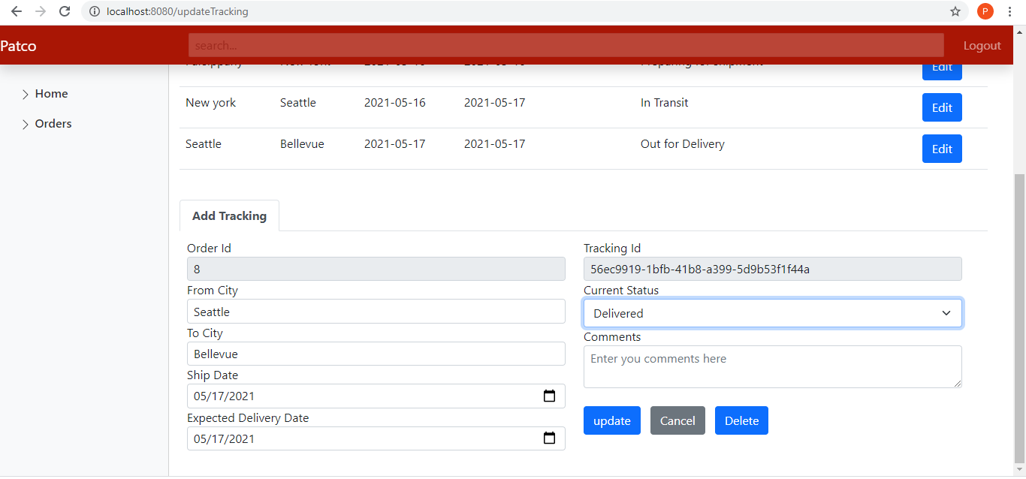

Figure 5.4: Tracking Order Update Portal

## **5.4 Logout**

Clicking on the Logout button allows the users to safely logout from the system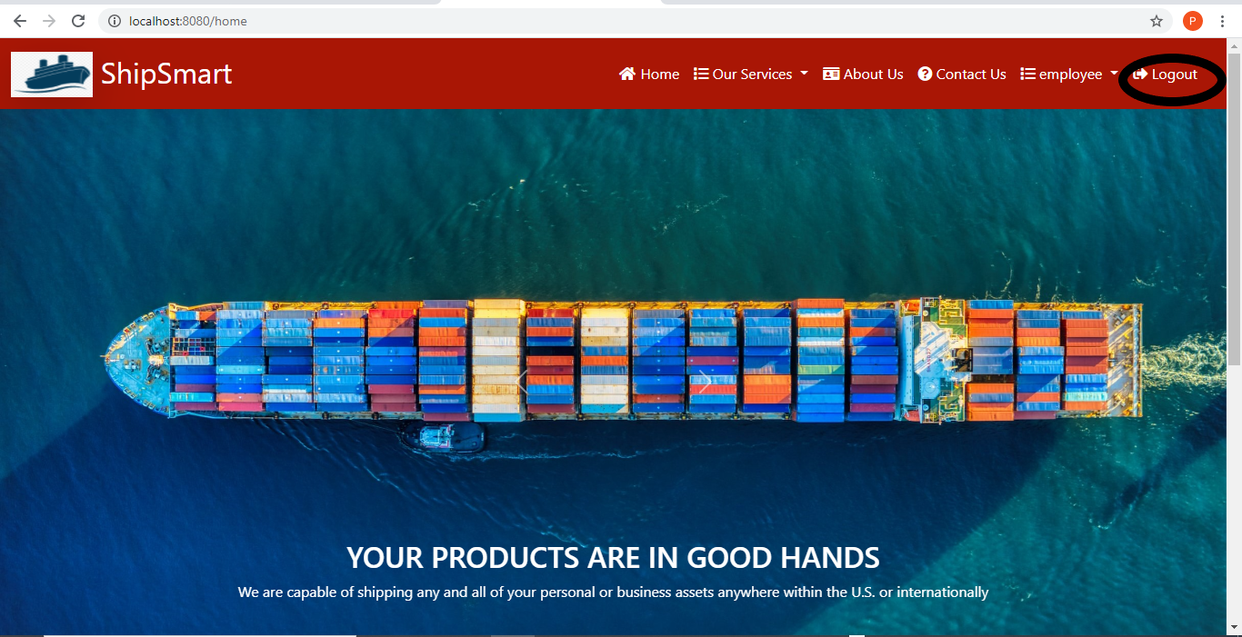.

Figure 5.5 Logout